**Software Requirements**

**Specification**

**for**

**Dash-R-Come**

**Version 1.0 approved**

**Prepared by**

**Evangelista, Harley.**

**Devera, Emmanuel S.**

**Fernandez, Alyssa.**

**Matawaran, Miguel Enrico.**

**MI 151**

**February 19, 2018**

# Table of Contents

Table of Contents ii

Revision History ii

1. Introduction 1
   1. Purpose 1
   2. Document Conventions 1
   3. Intended Audience and Reading Suggestions 1
   4. Product Scope 1
   5. References 1
2. Overall Description 2
   1. Product Perspective 2
   2. Product Functions 2
   3. User Classes and Characteristics 2
   4. Operating Environment 2
   5. Design and Implementation Constraints 2
   6. User Documentation 2
   7. Assumptions and Dependencies 3
3. External Interface Requirements 3
   1. User Interfaces 3
   2. Hardware Interfaces 3
   3. Software Interfaces 3
   4. Communications Interfaces 3
4. System Features 4
   1. System Feature 1 4
   2. System Feature 2 (and so on) 4
5. Other Nonfunctional Requirements 4
   1. Performance Requirements 4
   2. Safety Requirements 5
   3. Security Requirements 5
   4. Software Quality Attributes 5
   5. Business Rules 5
6. Other Requirements 5

Appendix A: Glossary 5

Appendix B: Analysis Models 5

Appendix C: To Be Determined List 6

# Revision History

|  |  |  |  |
| --- | --- | --- | --- |
| **Name** | **Date** | **Reason For Changes** | **Version** |
|  |  |  |  |
|  |  |  |  |

# Introduction

## Purpose

The proposed project is an Incident Reporting System. The system allows the user to send a video footage or picture of an incident using android device to the system’s web server or google cloud storage with a description of the incident. The system’s web server or google cloud storage will be manned by the Barangay Magallanes employees. The mobile application is named DASH-R-COME, the mobile application name was composed from the objective before which was to respond quickly. The mobile application runs in Android devices. Incident includes road accident, crime, traffic violators, and exploitation of traffic officers. The user must have a video footage or picture of an incident captured in either using a dashboard camera or android devices. The user is required to have an Internet connection or mobile data to use the mobile application.

The process of the application, If the user used a dashboard camera to capture the video, then, the user should transfer the video footage or picture to the android device using Bluetooth of dashboard camera, it’s only applicable if the dashboard camera has a Bluetooth feature. Otherwise, the user must transfer the memory card of dashboard camera to the android device and save the video footage or picture to the android device’s file system, such as Gallery. If the user used an Android device in capturing a video footage or picture of an incident, then the user can simply save the video footage or picture to the android device’s file system.

The video cutter feature, the user can use third party software where the user can cut unnecessary clip. The importance of cutting the unnecessary part is less consumption of the memory and less-usage of mobile data/Wi-Fi connection. If the user used the feature of ‘Take a snap’ feature, it will only limit to 30 seconds, after 30 seconds the user can either delete or save the captured video footage, thereafter the user can take another 30 seconds video footage. After the user has the video footage or picture saved in his/her android device, then the user can upload the video footage or picture to the system’s web server or google cloud storage using the mobile application. The uploaded video will be analyzed by the person in-charge of monitoring the web server or google cloud storage in Barangay Magallanes. Analyzing the video means to categorize the incident type, such as crime, traffic violators, and exploitation of traffic officers, fire. After analyzing the incident report, the employee in-charge will generate an incident report which will be forwarded to the leading designated agency.

## Document Conventions

The proposed project is an incident reporting system. The team aims to help Barangay Magallanes expand their services in terms of receiving incident reports or complaints. Barangay Magallanes receives incident reports and complaints using their hotline. The problem in their current system, according to Police Chief Inspector Samuel Melchor Fernandez, is that the agency cannot verify if the report is true. The team found this as an opportunity for the project implementation. Using the proposed system, Barangay Magallanes will receive a picture or video of the incident online. For the user side, the user is the one sending the incident report to the web server or google cloud storage. Which will be monitored by the Barangay Magallanes employee.  The Barangay Magallanes employee will call for the nearest concerned agency.

## Intended Audience and Reading Suggestions

The project manager, developer, and analysts are the group of people working to create the system. It is crucial for the group to know the most commonly incidents in the Barangay Magallanes. The users and employees, in addition, need to understand the how to use the system created by the group. The importance of parts of the document, however, is the introduction, results and implementation.

## Product Scope

The scope of the project is the Barangay Magallanes. The group target users of the mobile application are the motorists, bystanders, constituents and android device users. For the user to use the mobile application, the user must register to the mobile application and must have an internet connection or mobile data. Also, the user must have a picture or video footage of the incident captured that will be uploaded later to the web server or google cloud storage, which is being operated by Barangay Magallanes employee. In capturing pictures or videos, the user has three options, first, the user can use dashboard camera and transfer to the android device with its Bluetooth feature (the two devices must have a Bluetooth capability), second, if the user had captured the video footage with his/her android device, it must save in the android’s file system such as, Gallery and upload in the application from the file system, and third, the ‘take a snap’ feature to directly capture the video footage in the application that has 30 seconds limitations. If the user does not have an internet connection, then the application cannot be used to emergency

## References

Evidence handling is important to have solid proof to a certain incident (Sec. Rogelio Singson, 2017)

Always eager to serve if it means doing the job themselves (Francis Tolentino, 2017)

# Overall Description

## Product Perspective

The system is an additional system for the Barangay Magallanes in handling incidents on the compound vicinity. The proposed system will automatically store the video or picture on the web server or google cloud storage of the incident happened in the Magallanes City. The employee who manned will analyze and make a report due its jurisdiction.

## Product Functions

* Web server or Google Cloud Storage to store the incident video or picture that has been captured.
* Login system feature to authenticate the user and to avoid fake reporters.
* 'Take a snap' feature that allows user to send only a picture of an event.
* DashCamBlue feature that allows user to transfer the video footage of the incident from the dashboard camera to the android device.
* 30 seconds limitation for capturing to video footage to reduce the memory used.

## User Classes and Characteristics

The employee of the Barangay Magallanes will be responsible to monitor the web server or google cloud storage. The employee must generate a report if the video or picture that have been captured with a description details is valid to the classification of incidents. If it is valid, the employee will take an immediate action for the incident. Whenever the incident is not on the Magallanes Makati. The employee can call or contact the other agency for help.

## Operating Environment

The system is only accessible in Barangay Magallanes. The system will be manned by Barangay Magallanes Employee. The Barangay Magallanes Employee is responsible for analyzing, categorizing and validating the incident report.

## Design and Implementation Constraints

The Barangay Magallanes claimed that the internet connection is stable, computer is handled by their employers and employees are working 24/7. It would be difficult for the group to only store the data on its web server that is why the group decided to go to the Google cloud storage. So that, it can be accessed all the time.

## User Documentation

**Overview**

The mobile application has functions that will enable each user to send the incident that they encounter. A brief description is optional.

.

## Which devices does the mobile app support?

You can install the given application on any mobile devices that have Android operating systems.

## Basic Steps for Users

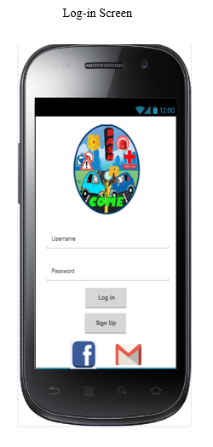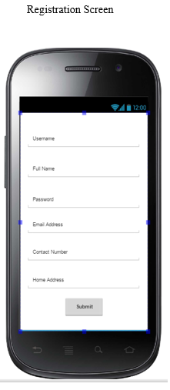

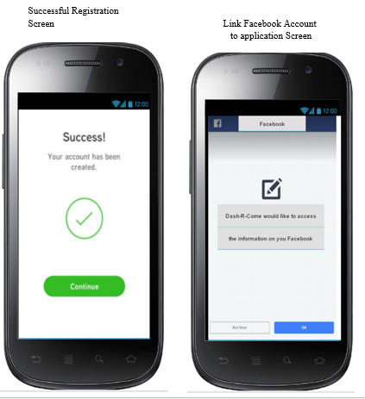

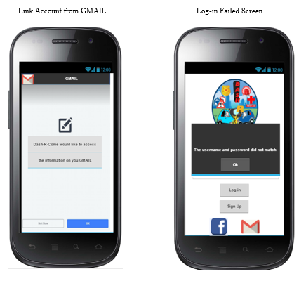

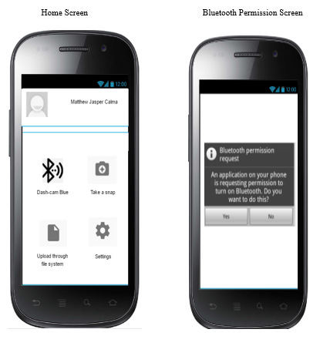

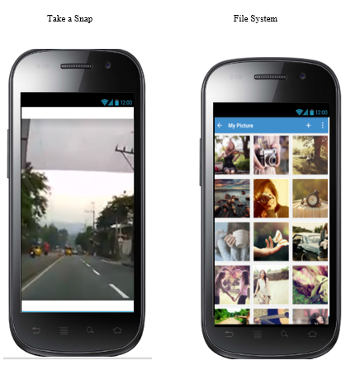

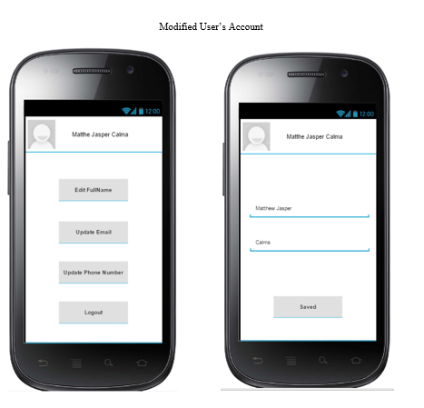

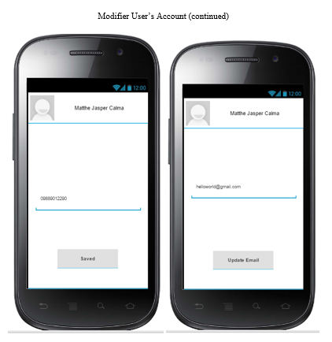

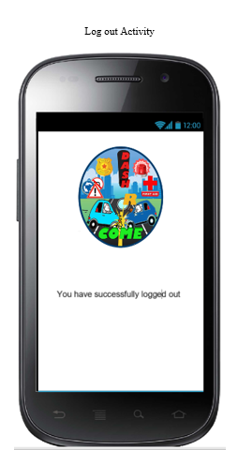

## Assumptions and Dependencies

The department heads don’t need to assign an employee for the ticket created by the front desk. The system will automatically send the generated ticket to the employees working on a particular shift.

# External Interface Requirements

## User Interfaces

## Home Screen

## 

## Hardware Interfaces

Dash-R-Come is a mobile application intended to be installed on an Android smartphone. The mobile application will be supported by the Google Cloud Storage and node PC of Barangay Magallanes. The node PC will be also the storage of the registration of the users' information.

## Software Interfaces

Dash-R-Come mobile application is being developed using Android Studio which can be installed in a mobile device. Integrated with Google Cloud Platform.

# System Features

## System Feature 1: Bluetooth Transfer of Files

### Description and Priority

### High Priority

### Stimulus/Response Sequences

### Step 1: Login to the mobile application

### Step 2: On the home activity click the blue icon and application will request for the permission to access the Bluetooth functionality to send or receive a file.

### 

### Functional Requirements

### A file can be receive or transfer through the Bluetooth. Permission are required to accept.

## System Feature 2: DashCamBlue

### Description and Priority

### High Priority

### Stimulus/Response Sequences

## 

### Step 1: Login to the mobile application.

### Step 2: On the home activity click the camera icon and application will redirect you to the camera to take some photo or video.

### 

4.2.3 Functional Requirements

To capture an incident if something’s happened. A picture or video will be a good primary source of evidence.

## System Feature 3: Upload through Web or Google Cloud

## 

### Description and Priority

### High Priority

### Stimulus/Response Sequences

## 

### Step1: Login to the mobile application

### Step 2: On the home activity click the gallery icon and application will redirect you to the gallery to send either to the web server or google cloud storage.

4.2.3 Functional Requirements

To have the reports analysis, the system should be connected to the internet and also the user should have internet connection in order to send the file.



# Other Nonfunctional Requirements

## Performance Requirements

The new ticket should only take a few seconds to be in the database. Viewing and creating are not an issue to system for the system would have a real time database.



## Safety Requirements

The Requests Ticket Management System will not affect any applications installed on the smartphone or any internal components on it.

## Security Requirements

The Requests Ticket Management System can only allowed employees that are registered to do the viewing ticket.

## Software Quality Attributes

The Requests Ticket Management System has a user friendly interface that is good for the employees to navigate. The application then will deal with submitting correct data to be able to obtain a clear and concise analyzed reports.

## Business Rules

The Requests Ticket Management System includes the Guest Service Representative, Employees which are from different departments, and the Executives. The guest service representative will only be the one who will create the ticket, and the employees are the first ones who will view it and the executives will be notified if the requests is not yet resolved with the allotted time.

# Other Requirements

# Here are the details and the needed data that the database should have.

# 

# 